Geco ReactJS Training
ReactJS Assignment
Name: | Ho Choo Geok
Date of Submission: | 19th October 2022
Cohort No.: | 27
Week No.: | 2
Daily Task No.: | 7 & 8
- Create employee data in a data.js file and include following fields (name, age, DOB, salary, designation, image, department).
Display name, image, designation in UI. Whenever user hover over any name, display complete employee data in alert/modal.

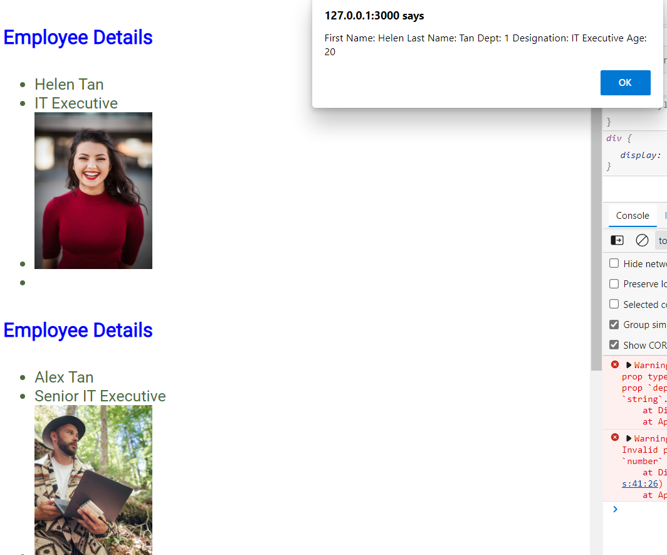
When mouseOver the name, alert box will display the details of the employee

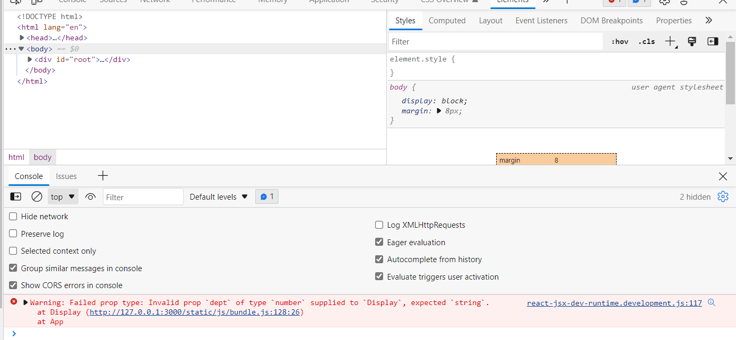
PropType of dept is defined as string, when the dept data is change from string to number proptype displayed error in the console
File Name:App.js
import React from "react";
import data from "./data";
import "./App.css";
import Display from "./Display";
const App = () => {
const dataElements = data.employeeDetails.map((items) => {
return (
<Display
id={items.id}
firstName={items.firstName}
lastName={items.lastName}
age={items.age}
dept={items.dept}
dob={items.dob}
designation={items.designation}
address={items.address}
image={items.image}
/>
);
});

return (
<>
{dataElements}
</>
);
};
export default App;

File Name: Display.js
import React from 'react';
import "./App.css";
import PropTypes, { func } from 'prop-types';
function Display(props) {
function handleChange(id) {
return(
alert("First Name: " + props.firstName + " " + "Last Name: " + props.lastName + " " + "Dept: " + props.dept + " " + "Designation: " + props.designation + " " + "Age: " + props.age)
)}
return(
<div>
<h4> Employee Details</h4>
<ul>
<li onMouseOver={() => handleChange(props.id)}>{props.firstName} {props.lastName} </li>
<li>{props.designation} </li>
<li><img className="personImage" src={props.image} alt="image" /> </li>
<li> </li>
</ul>
</div>
)}
Display.propTypes = {
firstName: PropTypes.string,
lastName: PropTypes.string,
designation: PropTypes.string,
dept: PropTypes.string,
age: PropTypes.number,
}
export default Display;

- Create an array of grocery data, send data from 1 component to another and display it
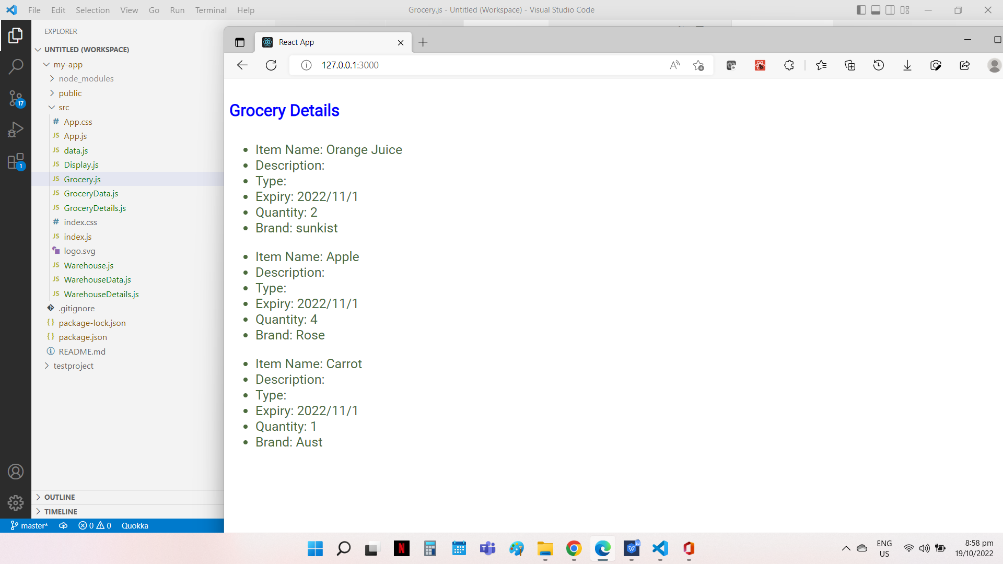
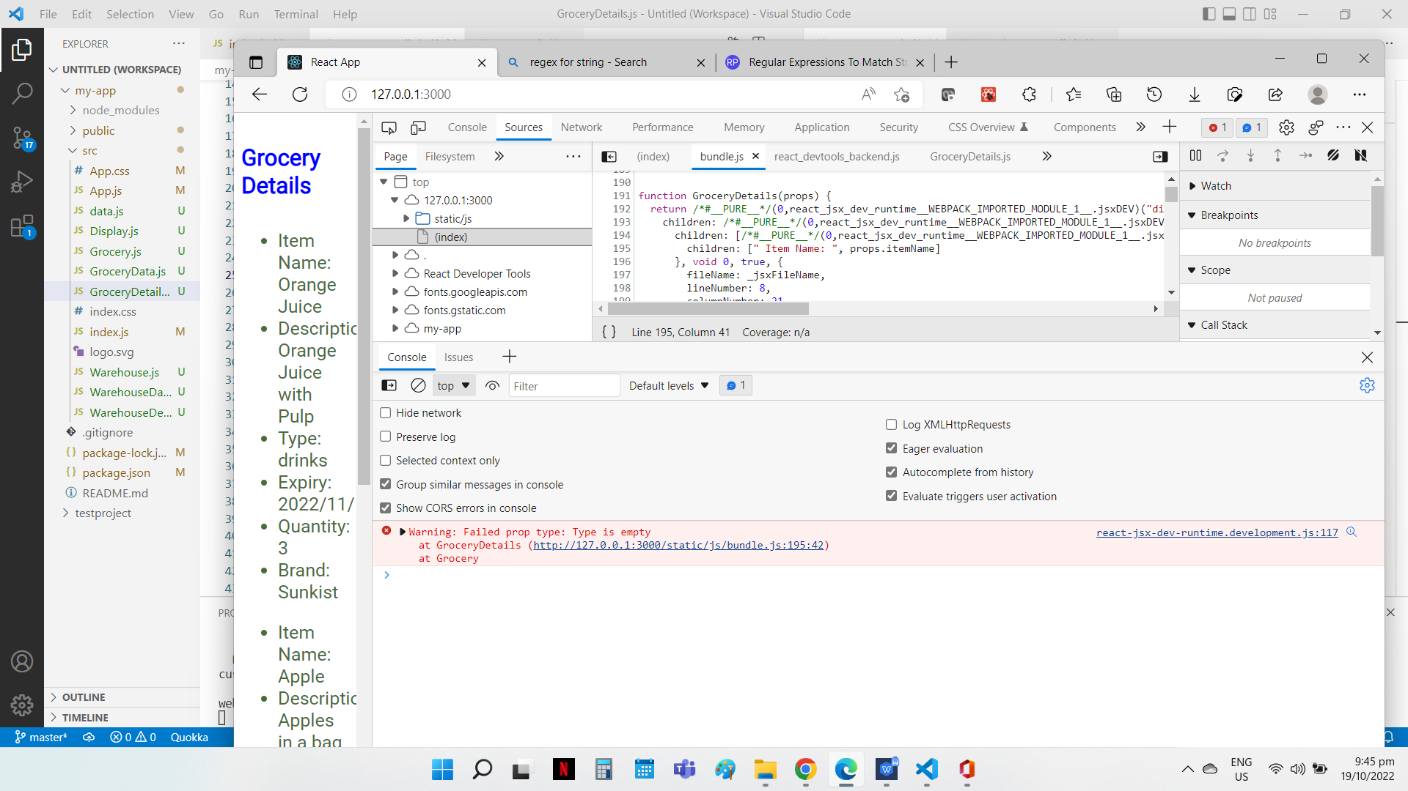
Custom Validation
To check that the Type is not an empty string
Display of Grocery Details

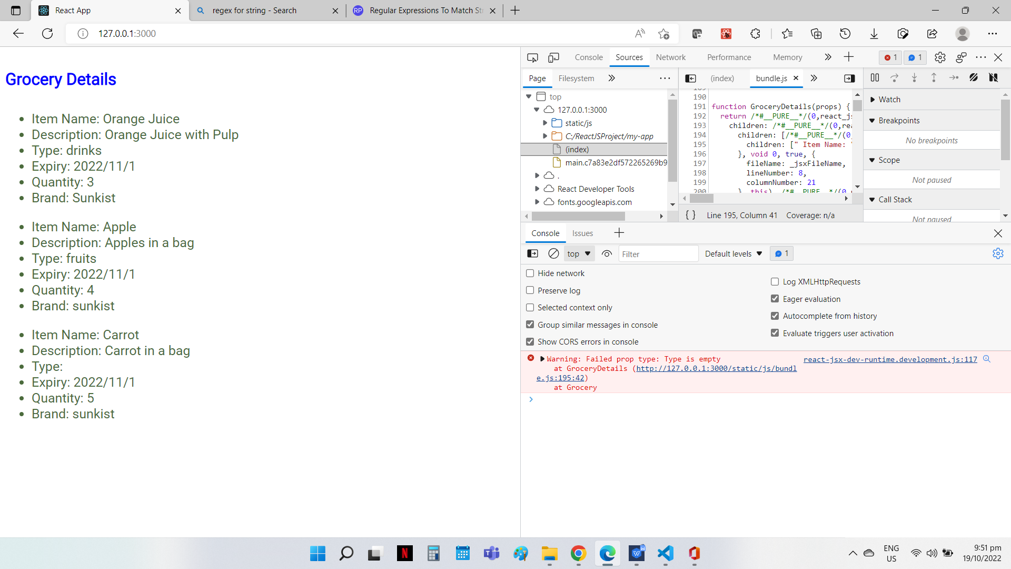
Default Props
To remove the brand for item 2 and 3. The default value is displayed.

File Name: GroceryDetails.js
import React from "react";
import PropTypes from 'prop-types';

function GroceryDetails(props){
return (
<div>
<ul>
<li> Item Name: {props.itemName}</li>
<li> Description: {props.description} </li>
<li> Type: {props.type} </li>
<li> Expiry: {props.expiry} </li>
<li> Quantity: {props.quantity} </li>
<li> Brand: {props.brand} </li>
</ul>
</div>

);
}

// To check that type is not an empty string
const isType = (props, propName) => {
let regex = /^$/g ;
regex.test(props.quantity);
if (regex.test(props[propName])) {
return Error('Type is empty');
}
}

//Validation of the propTypes
GroceryDetails.propTypes = {
itemName: PropTypes.string.isRequired,
description: PropTypes.string,
type: isType,
expiry: PropTypes.string,
quantity: PropTypes.number,
brand: PropTypes.string,
}

//Default value for the props
GroceryDetails.defaultProps = {
itemName: "Orange Juice",
description: "Orange Juice with Pulp",
type: "drink",
expiry: "2022/11/1",
quantity:2,
brand: "sunkist"
}

export default GroceryDetails;
File Name: Grocery.js
import React from "react";
import GroceryDetails from "./GroceryDetails";
import GroceryData from "./GroceryData";
import "./App.css"

const Grocery = () => {

const groceryElements = GroceryData.details.map( (item) => {
return(
<GroceryDetails
key={item.id}
itemName={item.itemName}
description={item.description}
type={item.type}
expiry={item.expiry}
quantity={item.quantity}
brand={item.brand}
/>
)
})

return (
<>
<h4> Grocery Details </h4>
{groceryElements}
</>
);
};
export default Grocery;

File Name: GroceryData.js
const data = {
details: [
{
id: 1,
itemName: "Orange Juice",
description: "Orange Juice with Pulp",
type:"drinks",
expiry: "2022/11/1",
quantity:3,
brand: "Sunkist",
},
{
id: 2,
itemName: "Apple",
description: "Apples in a bag",
type: "fruits",
expiry: "2022/11/1",
quantity:4,

},
{
id: 3,
itemName: "Carrot",
description: "Carrot in a bag",
type:"",
expiry: "2022/11/1",
quantity:5,

},
],
};
export default data;

- Create an object pass data from 1 class based to another class based data and display it (Hint: this.props).

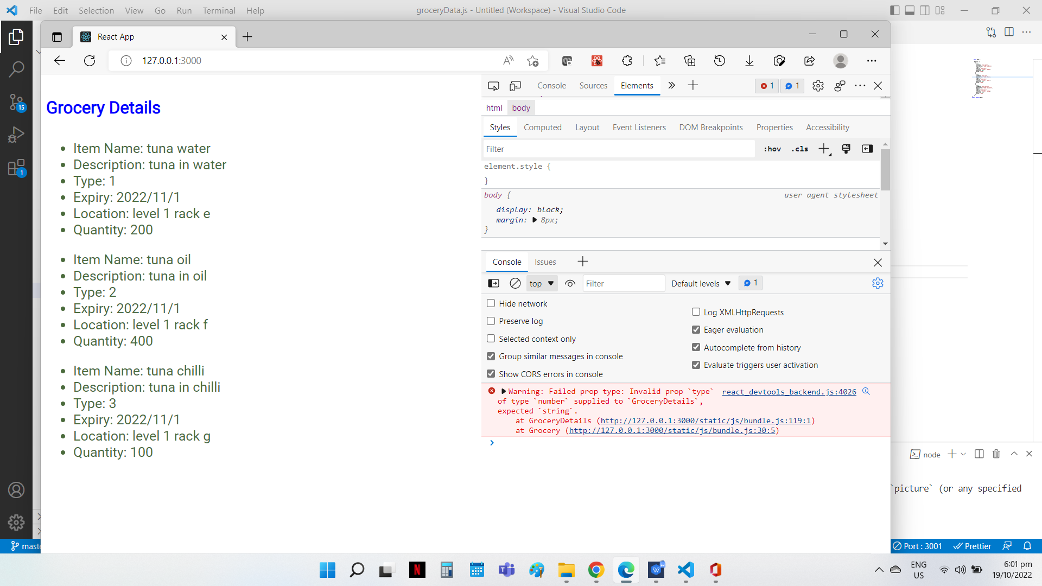
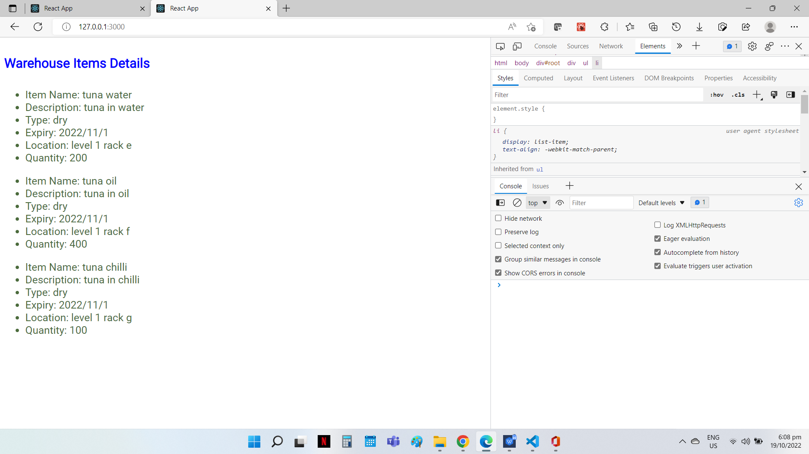
Display of Warehouse Details
Prop Type Validation
Change of Type from string to number, prop type error prompt in console

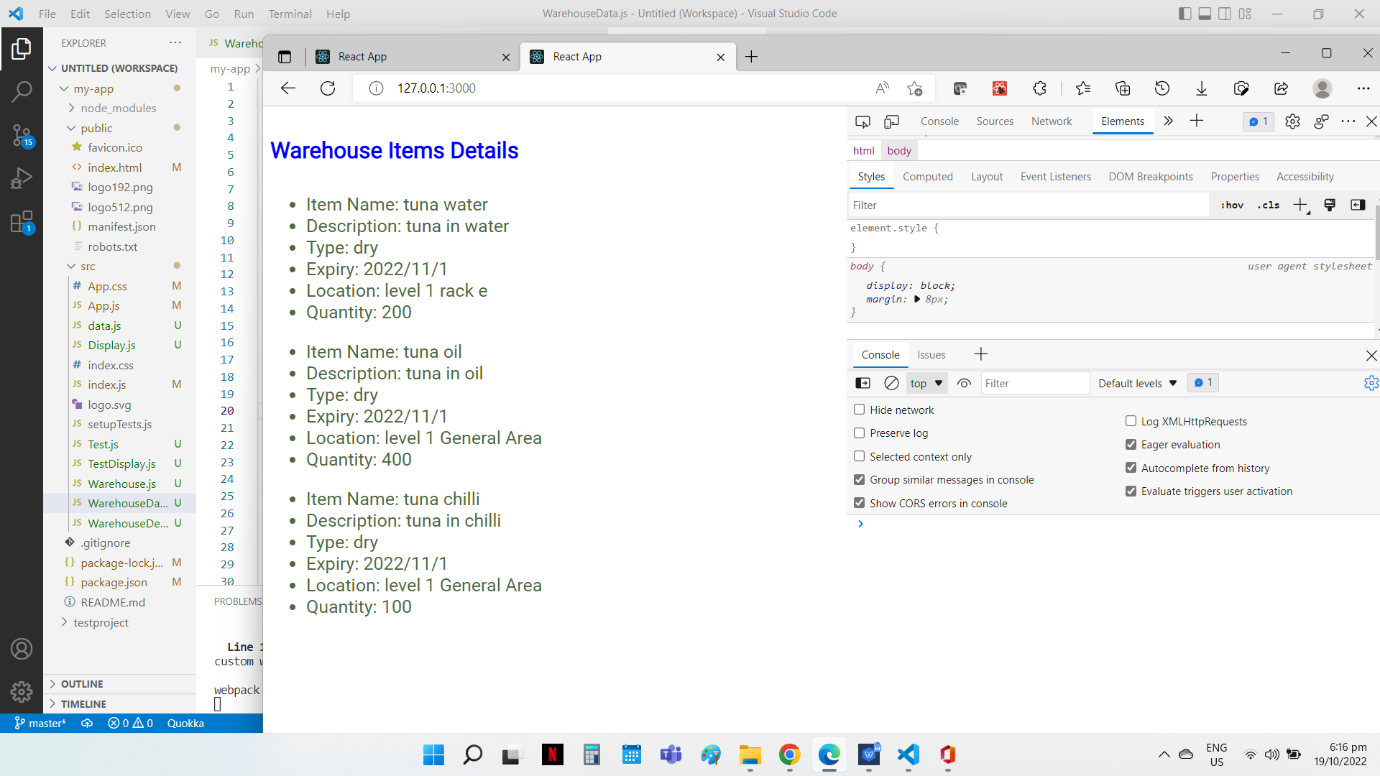
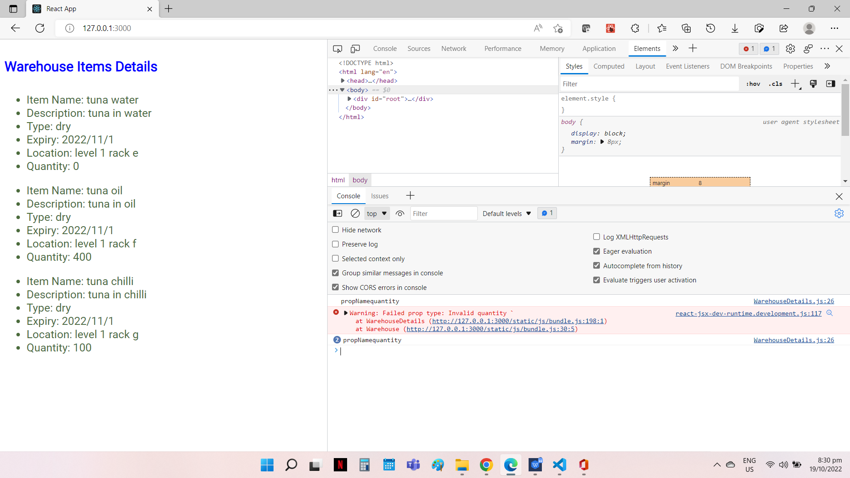
Default Props
when the location details are not available in tuna oil and tuna chilli, the default value is displayed
Custom Validation
To check that the quantity is between 1 to 100. Error prompt in console when quantity is set to 0.

File Name: WarehouseDetails.js
import React, { Component } from "react";
import "./App.css";
import PropTypes from 'prop-types';

class WarehouseDetails extends Component {

render() {
return (
<div>
<ul>
<li>Item Name: {this.props.itemName} </li>
<li>Description: {this.props.description} </li>
<li>Type: {this.props.type} </li>
<li>Expiry: {this.props.expiry} </li>
<li>Location: {this.props.location} </li>
<li>Quantity: {this.props.quantity} </li>
</ul>
</div>
);
}
}

// To check that Quantity is between number of 1-100
const isQuantity = (props, propName, componentName) => {
console.log('propName'+ propName);
let regex = / [1-100] / ;
regex.test(props.quantity);
if (!regex.test(props[propName])) {
return Error('Invalid quantity `');
}
}

//Validation of the propTypes
WarehouseDetails.propTypes = {
itemName: PropTypes.string.isRequired,
description: PropTypes.string,
type: PropTypes.string,
expiry: PropTypes.string,
location: PropTypes.string,
quantity: isQuantity,
}

//Default value for the props
WarehouseDetails.defaultProps = {
id: 1,
itemName: "tuna water",
description: "tuna in water",
type: "dry",
expiry: "2022/11/1",
location: "level 1 General Area",
quantity: 200,
brand: "ayam"
}

export default WarehouseDetails;

File Name: Warehouse.js
import React, { Component } from 'react';
import WarehouseDetails from "./WarehouseDetails";
import groceryData from "./WarehouseData";

class Warehouse extends Component {

warehouseElements = groceryData.details.map( (item) => {
return(
<WarehouseDetails
key={item.id}
id={item.id}
itemName={item.itemName}
description={item.description}
type={item.type}
expiry={item.expiry}
location={item.location}
quantity={item.quantity}
/>
)});

render(){
return(
<>
<h4> Warehouse Items Details</h4>
{this.warehouseElements}
</>
);
}

};
export default Warehouse;

File Name: WarehouseData.js
const data = {

details: [
{
id: 1,
itemName: "tuna water",
description: "tuna in water",
type: "dry",
expiry: "2022/11/1",
location: "level 1 rack e",
quantity: 0,
brand: "ayam"
},
{
id: 2,
itemName: "tuna oil",
description: "tuna in oil",
type: "dry",
expiry: "2022/11/1",
location: "level 1 rack f",
quantity: 400,
brand:"ayam"
},
{
id: 3,
itemName: "tuna chilli",
description: "tuna in chilli",
type: "dry",
expiry: "2022/11/1",
location: "level 1 rack g",
quantity: 100,
brand:"ayam"
},
]
}
export default data;

